• Discuss maturation of motor skills.
For this objective, you will be considering several stages when developmental milestones occur during infancy and toddlerhood. For a resource, you will use the website found here: https://www.emedicinehealth.com/infant_milestones/article_em.htm
For the activity, I want you to consider a toy that could be given as a gift to a baby that would be appropriate for each developmental stage that is listed, and explain why each toy you select would be appropriate for that age based on the maturation of their physical abilities.
For example:
Age/Stage | Developmental Milestone | Toy you would select | Why would that toy be appropriate?
Ex. First month | Mouthing reflex, gripping reflex, stepping reflex, prefers black and white over color | 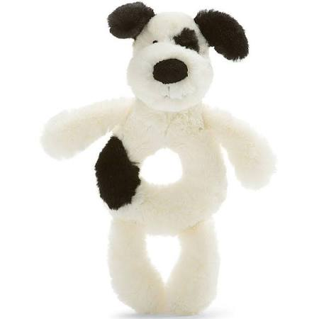  Black and white plush puppy ring rattle | Because in the first month, babies put things in their mouths, this would be appropriate because there are no small parts. It also is meant to grasp, so it supports the grip reflex, it is also black and white, which is a developmental preference at this age.
1-3 months
4-7 months
8-12 months
Toddler

